**EARTH DAY PROJECT FOR GIFTED CLASS**

**Xavier (4th Grade)**

**The Problem:**

The Pacific Garbage Patch is filled with trash and it is hurting sea life and maybe humans too.

**The solution:** my idea to clean the Pacific Garbage Patch is to get big water-proof drones that will grab the garbage and put it in bags and put full bags on a cargo ship their claw will be 6 feet long and wide

I will make drones go out to sea and put the trash in bags and put full bags on a cargo

ship and keep doing it until the day are over and then they will charge to do it again tomorrow.

**The Research:**

*Drone:*

the Griff 300can lift 595 lbs.

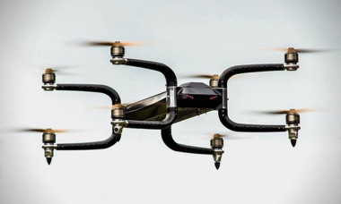

*Sea life:*

Plastic makes up 74% of the diet of sea turtles that enter the area ending in a quick

death.

*Pacific garbage patch:*

* the garbage patch weighs 3.5 trillion ton of plastic
* contains plastic that is decades old
* it is roughly three times the size of France
* it was discovered by Charles Moore
* almost half the garbage patch is made of fishing nets
* it is one of five similar garbage patches
* the pacific garbage patch has between 1.1 to 3.6 pieces of plastic
* the plastic is under and above the water
* plastic cannot escape the patch
* the largest ocean clean-up is under way

**The Model Materials:**

* spy drone
* plastic bag
* blue paper